DAY 3 ASSIGNMENT
NAME: HARPUNEET KAUR
UID: 22BAI71102
A document providing all steps for publishing project using self contained and dependent mode.
STEPS:
- Create a new project by following the given steps on Visual Studio Community 2026:
- Click on New Project> Console App Template and click Next.
- Name it as “Day3Assignment” and click Next.
- Select “Do not use Top level statements” and create the project.
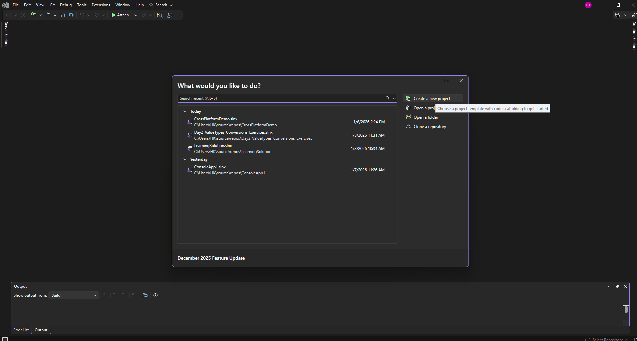
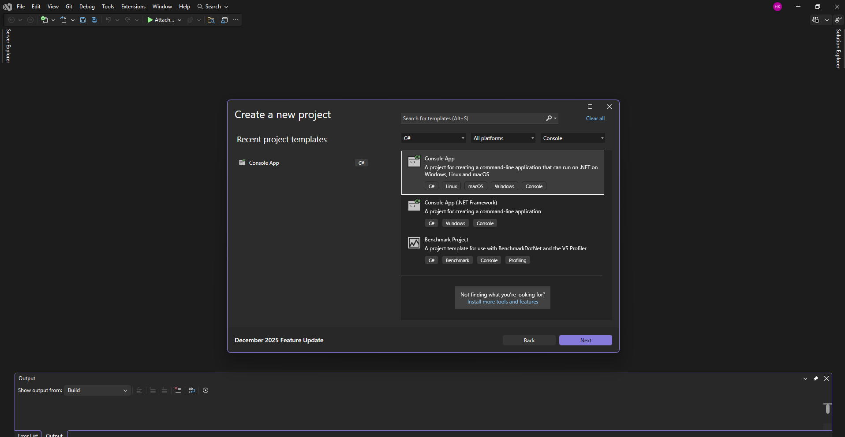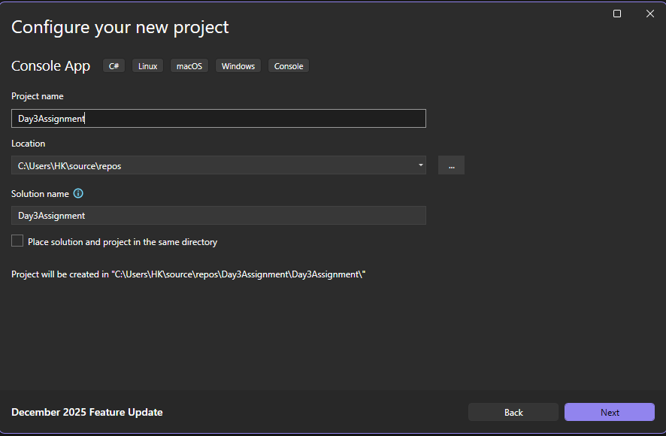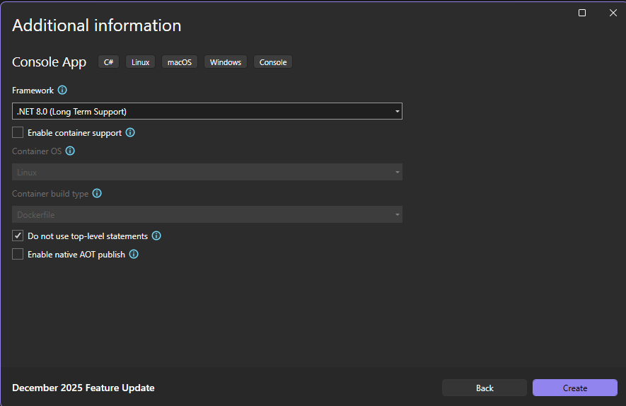
- Write the following code in the editor as shown and then run it.
- Click on the Solution Explorer.
- Right Click on the project name and select “Publish” from the drop-down menu.
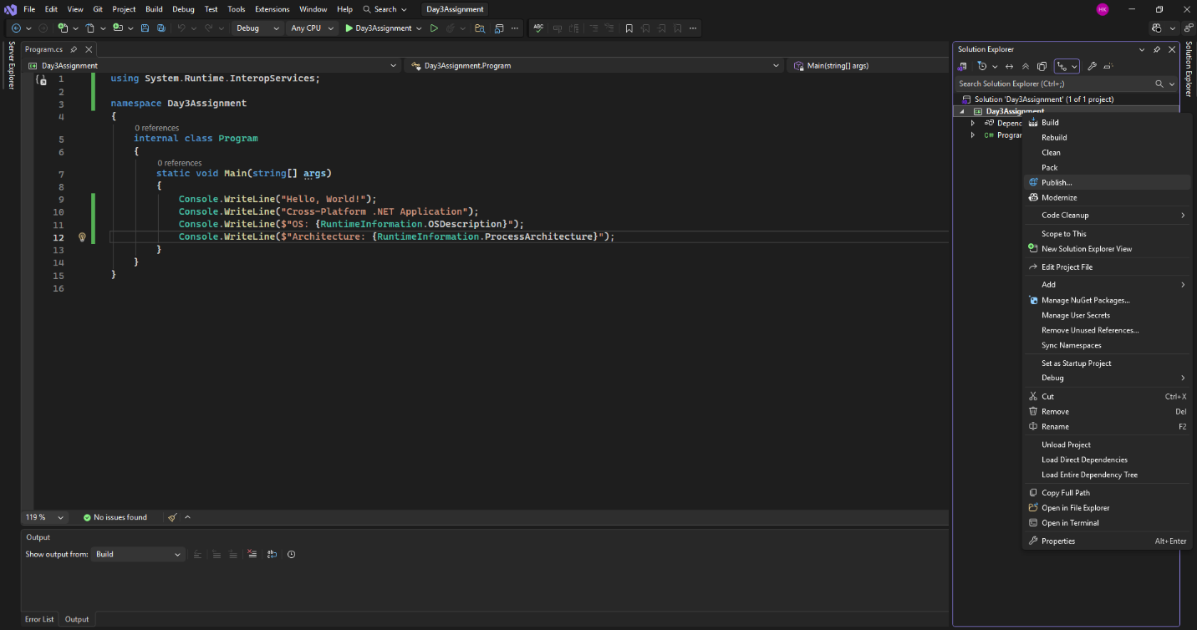
- Select “Folder” and click Next.
- Repeat the same step and then Click “Finish” and then close the window.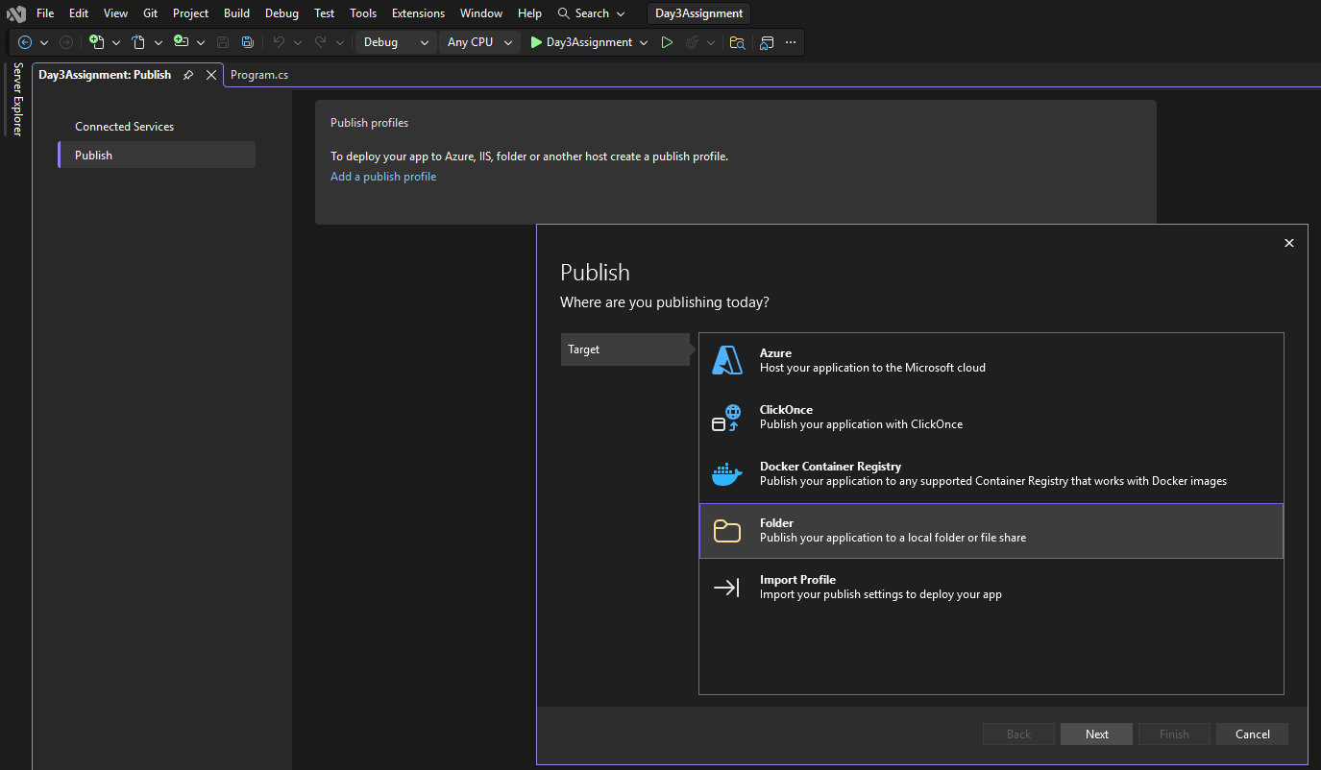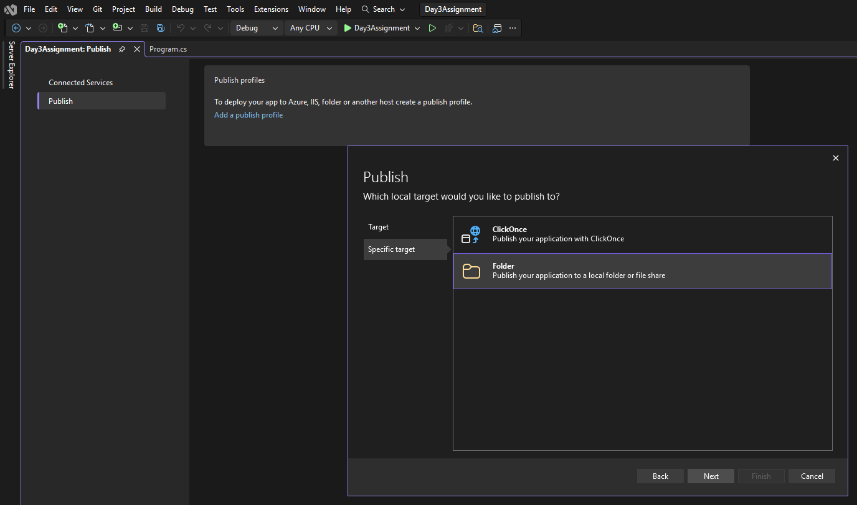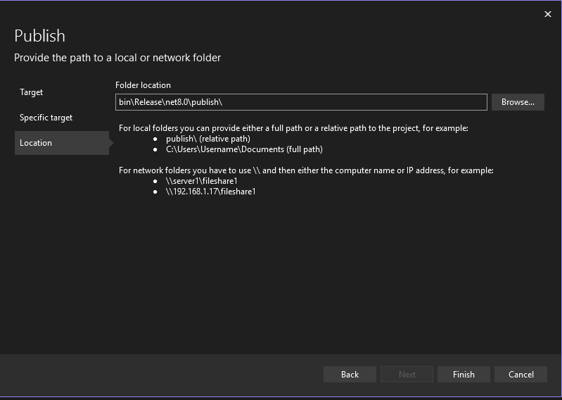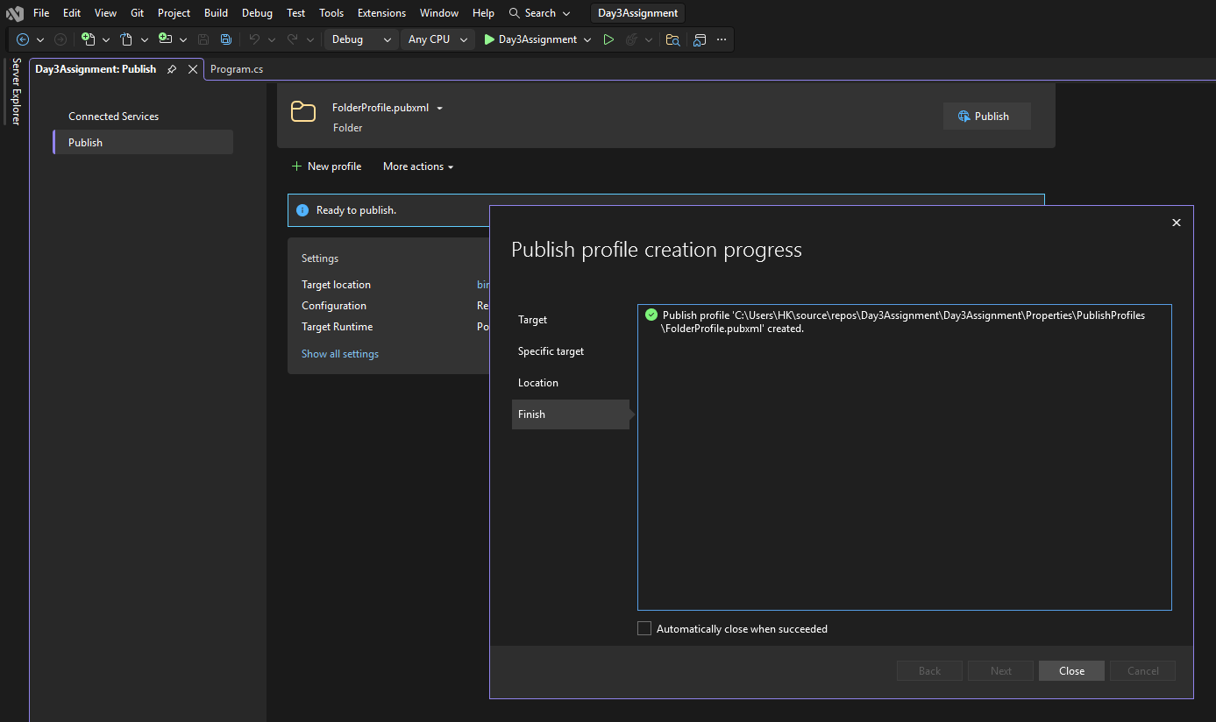 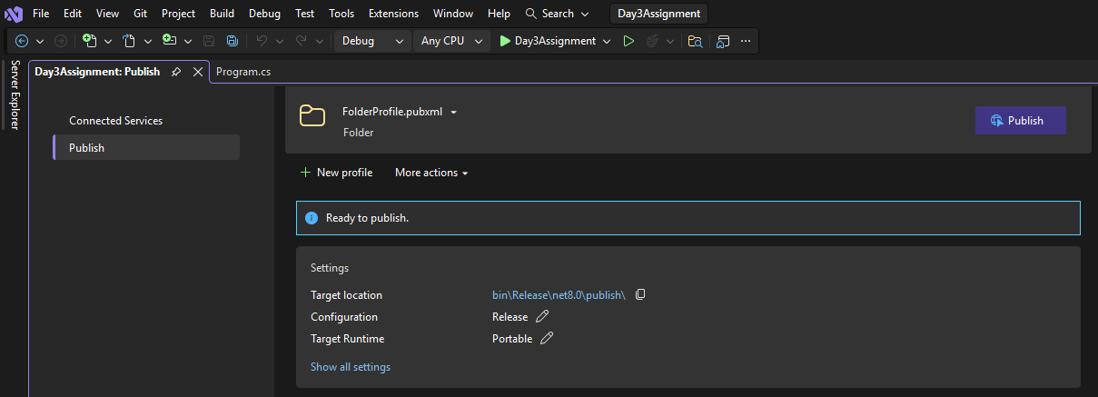
- Click on “More actions” > Edit, you will see a new window with some information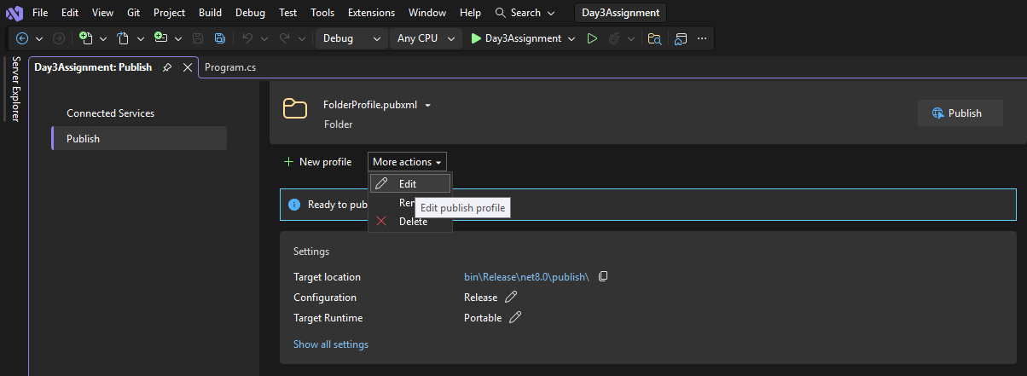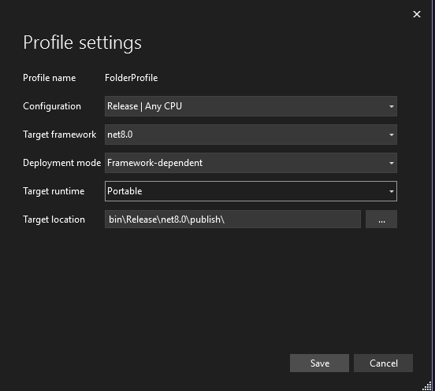
- Save the work and then click on Publish.
- Click on Navigate, you will get to see the following files in the file explorer.
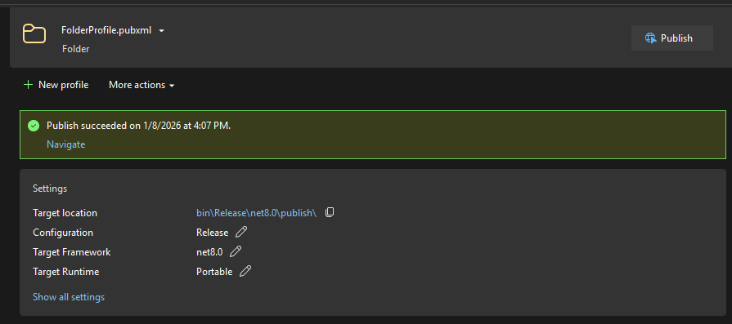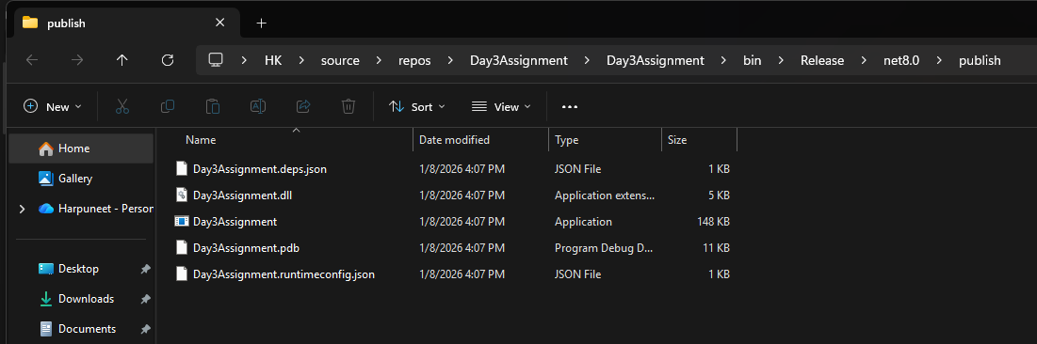

NOTE: By default, Visual Studio uses a framework-dependent, portable publish profile. So, OS options (win-x64 / linux-x64) and Self-Contained mode are not visible. Therefore, follow the given steps to change the configurations.
- Again, go back to the same Publish window and select “More actions” > Edit.
- Select “linux-x64” in Target Runtime and “Self-contained” in the Deployment Mode.
- Save the settings. Publish the project and Navigate to the file explorer to see the files.
